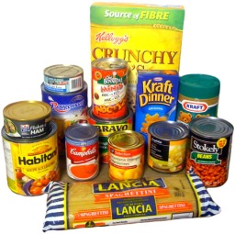C:\Users\alowe\AppData\Local\Microsoft\Windows\Temporary Internet Files\Content.IE5\FWB2E58B\MC900237315[1].wmfDominic College Christmas Outreach

2017

Classroom Food Hampers

St Vincent DePaul Food Hampers

Dear families,

This year, Dominic College are going to be collecting goods for class hampers. These hampers will be located in your child’s classroom.

We have provided a list of ideas of food items that are suitable for the hamper. However, feel free to bring in a different item than what is on the list.

**C:\Users\alowe\AppData\Local\Microsoft\Windows\Temporary Internet Files\Content.IE5\IPSS3WB6\MC900363562[1].wmf**The food hampers are going to be given to St Vincent De Paul. The baskets will be a part of the Offertory procession at our final K-9 Mass. We will arrange for a representative from St Vincent de Paul to come and collect the baskets after the mass. They will then be distributed to needy families in the Hobart area.

Thank you for your support and kindness.

Margaret Rootes

Coordinator of Religious Education K-6

|  |  |  |  |  |  |
| --- | --- | --- | --- | --- | --- |
| **Hamper Ideas** | | | | | |
| Christmas cake | Christmas pudding | Christmas novelties/  serviettes | Bon Bons | Soft Drink |  |
| Spreads | Children’s biscuits | Cereals | Dried fruit | Sweets |  |
| Shortbread | Coffee | Tea | Long life milk | Canned goods |  |
| Cooking staples | Crisps | Crackers or pretzels | Children’s activity books | Icy poles (self-freeze) |  |