Rowing is an Olympic Sport
Want to be part of your NCC rowing squad under the supporting umbrella of the Maroochy River Youth Rowing Club?

Rowing is an elite Olympic sport where you can row as an individual in a single scull boat or crew boats (double, quads & eights) where syncronised teamwork is paramount

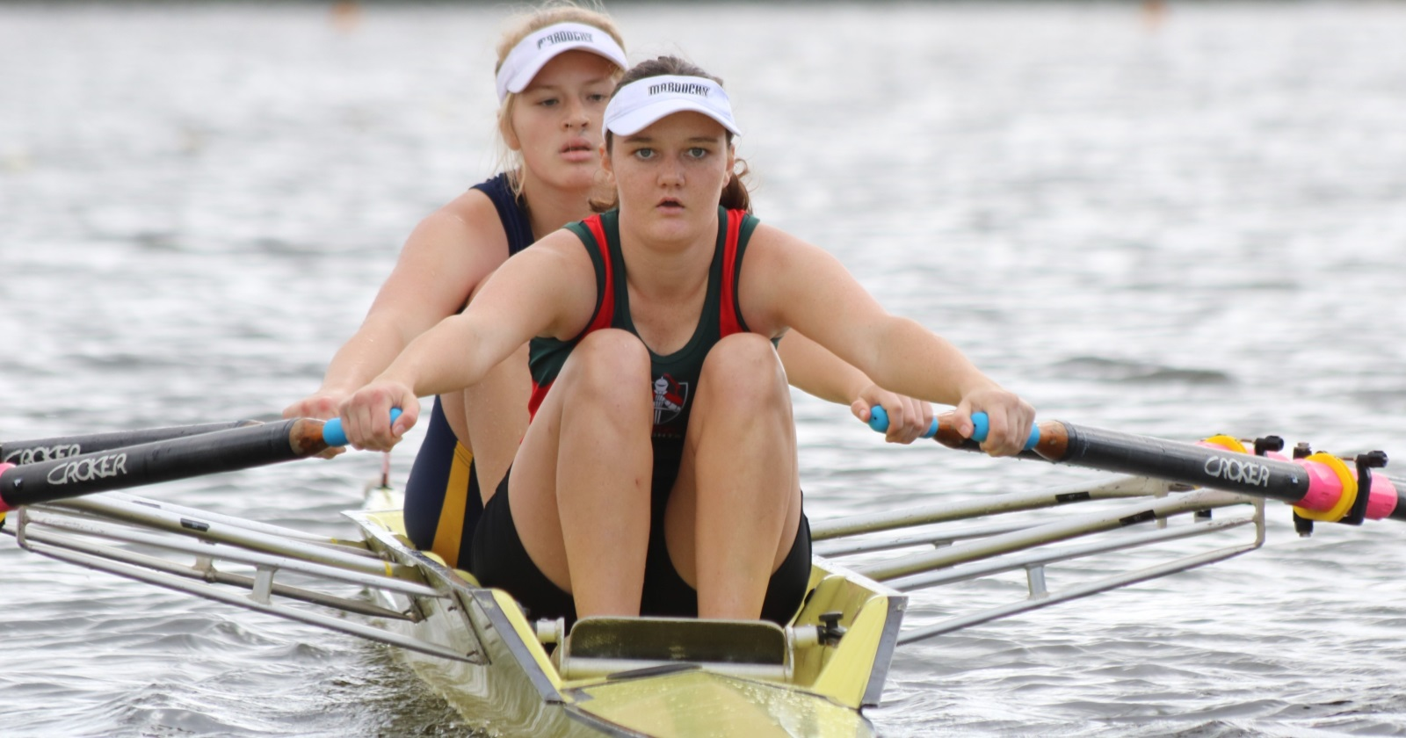
Girls and Boys Squads catered for from ‘Year 7’ Upwards

*ROWING is a full body exercise...legs, trunk and arms

* ROWING works on a ‘power for weight’ ratio....meaning, body size is not always relevant

* ROWING does require a considerable high level of discipline to achieve best results

* ROWING is the best cross-training sport to advance fitness and co-ordination

* ROWING is a non-contact sport and injuries are rare

Yes, rowing will strengthen you physically and mentally.....READY TO GIVE IT A GO NOW?

We’re centrally based at the only youth rowing base on Sunshine Coast, Muller Park, BLI BLI
Parents of students often ‘car pool for efficiency’

BEGINNER COURSES AVAILABLE DURING APRIL SCHOOL HOLIDAYS

Submit your interest or enquiry to info@maroochyriverrowing.com.au

